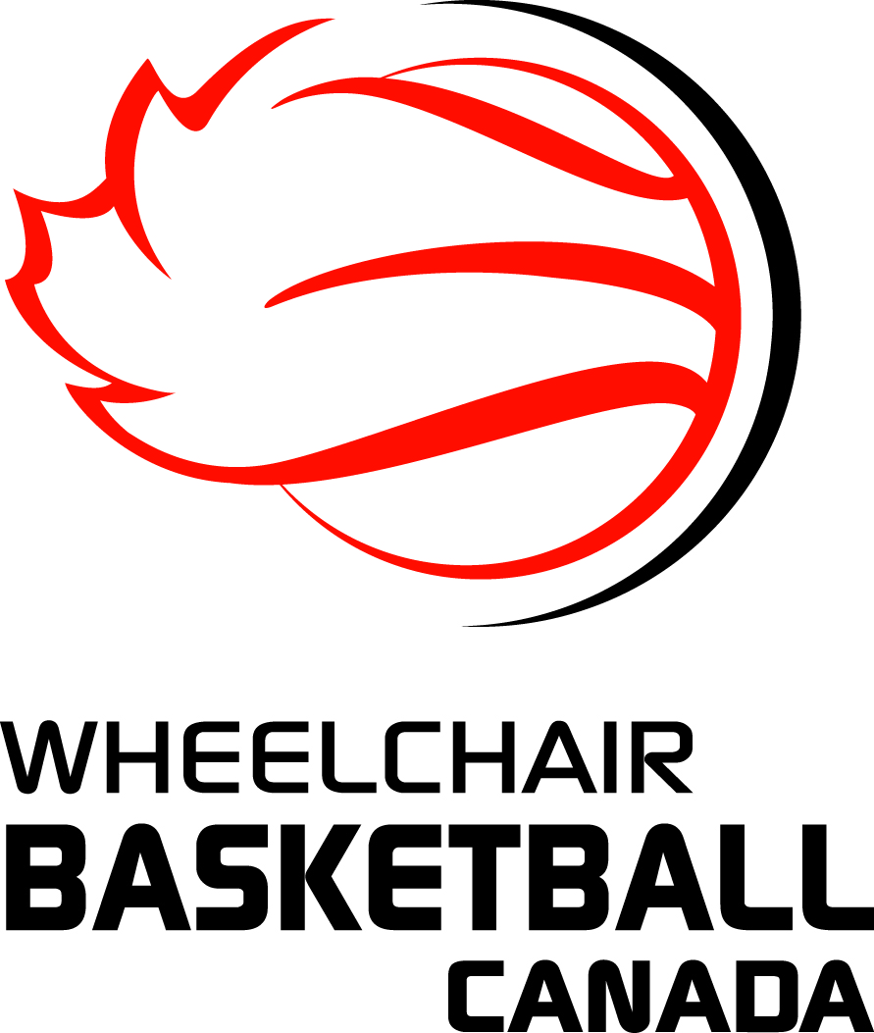
WHEELCHAIR BASKETBALL CANADA

2016-2017 Annual Officials Exam

This examination is open to anyone - official, coach, player or other - and will be used when selecting officials for post-season assignments. To be eligible for those assignments you must complete and pass the 2016-2017 examination by January 15, 2017.

The following documents were used as a basis for the questions in the examination:

- IWBF Rules V2 – January 1, 2016
- IWBF Comments and Interpretations V1 – January 15, 2015
- FIBA Interpretations 2nd Edition – November 1, 2015

NOTE: Team A is offence; Team B is defence

To properly test yourself, it is recommended that you try to answer these questions on your own, without external assistance, prior to using any resources.

PLEASE USE THE ANSWER SHEET ON PAGE 5 TO RECORD YOUR ANSWERS.

QUESTIONS

- B4 and A5, who has possession of the ball, are moving in parallel paths on the court. B4, who has his rear axle in front of the most forward part of A5’s chair, turns into A5’s path and, without making contact with A5, stops his wheelchair in the path of A5. A5 then contacts B4. The official assesses a blocking foul to B4. Was the official correct?
- A1 is straddling the centre line with two wheels in the frontcourt and two wheels in the backcourt. She receives a pass from A5 who is in her backcourt. She rotates her chair and both of the wheels touching the frontcourt return to the backcourt. The official whistles a violation for illegally returning the ball to the backcourt. Was the official correct?
- With 1:48 remaining in the 4th period, A1 scores a field goal. The horn sounds to notify the officials that A10 wishes to enter the game for A2. Upon hearing the horn, the official sounds his whistle, stops play and beckons the substitute in. Was he correct?
- Player B1 intercepts a pass in his back court near the 3 point line. A1, who is the last defender between the basket and B1, attempts to play the ball from the side. The contact was not hard but the official whistles the play dead and calls an unsportsmanlike foul on A1. Was the official correct?
- With the count at 6 sec. A2’s backcourt pass hits A3’s chair which is completely in the frontcourt. The ball bounces back to Team A’s backcourt where it is recovered by A2. The referee whistles the play down because his count is now at 8 sec. Was the official correct?
- Compression stockings are permitted provided they are the same colour as the shorts or white or black. Is this correct?
- The referee stops the game at an appropriate time to allow the team to repair an unsafe wheelchair. If the repair cannot be completed in 50 seconds or less from the time the game was stopped the player must be substituted. Is this procedure correct?
- With 0:35 sec. remaining in the extra period, A3 is dribbling the ball in Team A’s front court. B3 tips the ball into A‘s backcourt, where it is recovered by A2. Before A2 can move or make a pass, B2 holds A2. The foul is Team B’s 4th team foul in the period. Team A requests a time out which is granted. Following the expiration of the time out the officials put the ball in play at the point nearest the foul. Were they correct?
- With 4 sec. remaining on the shot clock, A1’s frontcourt pass is deflected by B5 and the ball goes into Team A’s backcourt. Just as A3 recovers the ball in the backcourt, A3 is fouled by B1. The foul is team B’s 3rd of the period. The officials reset the shot clock to 24 sec. and put the ball in play out of bounds at the point nearest to where the foul occurred. Were they correct?
- A3 is awarded 1 free throw. Prior to his release, A4 enters the restricted area followed by B4. The shot is not successful. The official sounds his whistle and awards the ball to team B on the end line. Was he correct?
- As a result of contact between A5 and B5 in Team A’s backcourt, B5 has fallen, is not able to get up and is in no danger of injury. Team A continues to attack B’s basket. A2’s first shot at B’s basket misses and is rebounded by A1. The official then blows his whistle to stop play and to allow B5 back in her chair. Was the official correct to do this?
- After a cancelled basket the official is about to hand the ball to A1 at the free throw line extended for a throw-in. A2 goes into the restricted area in A’s front court. The official whistles a violation on A2. Was the official correct?
- B4 lifts from his seat while attempting to block a three point try by A3 which falls well short. The official assesses a technical foul on B4 and awards A3 with a foul shot for the technical followed by throw-in at the centre line. Is this the correct procedure?
- Must a player who stops his wheelchair in a legal guarding position and covers the path of a moving opponent with the ball give the opponent time and distance to stop or change direction?
- A4 is in the act of shooting for a field goal when B4 attempts to distract A4 by shouting loudly. The shot for a field goal is unsuccessful. B4 is warned by the referee that if he does that for a second time he will be charged with a technical foul. Was the referee correct?
- At the same time as the game clock signal sounds to end the first period and with the possession arrow favouring Team B, B1 commits an unsportsmanlike foul on A1. A1 is awarded 2 free throws with no rebounders. After the two minute interval, the game is resumed with a throw-in by Team A at the centre line extended opposite the scorer’s table. Is this correct?
- May a player participate if he is only wearing socks on his feet?
- The eight second count will end when A4, in his backcourt, deliberately taps the ball onto B2 who is in A’s front court.
- Before the referee tosses the ball for the tap-off to commence the game, the scorer notices that team A has more than 14 points in its starting line-up and advises the referee. The referee assesses Coach A with a “C” technical foul, allows any member of Team B to shoot one free throw and then administers a tap-off to begin the game.
- A held ball situation occurs and A2 is going to make the subsequent throw-in. Before he releases the ball, A2 rolls onto the court. The referee whistles for the violation and the throw-in is awarded to Team B. At the same time the referee indicates that the next alternating possession shall favour Team B. Is he correct?
- Team B requests a time out with 34 seconds remaining in the last quarter. This is the third timeout requested by Team B in the last two minutes of the game. The official denies that request. Is that correct?
- A1 lifts his leg from the footrest and swings it to the side of his wheelchair in order to maintain balance while receiving a pass. Should a technical foul be charged against A1?
- In the course of play the footplate of B2 comes in contact with the wheel of ball carrier A1. In order to make a pass to his team mate, A1 who has both hands on the ball, hops his chair so that all wheels rise from the floor at the same time. The official charges A1 with a technical foul
- Near the end of the shot clock period A1’s pass is missed by A2 (both players are in their frontcourt) and the ball rolls into team A’s backcourt. Speedy B1 has a clear path to the ball and the basket. Just before he gains control of the ball the shot clock signal sounds. The official whistles the play dead. Was the official correct?
- With 1:30 left in the game, the referee is about to present the ball to A1 for a throw-in when B5 causes hard contact with A2. Was the official correct to call an unsportsmanlike foul on B5?
- With 17 seconds remaining on the shot clock, A1 releases a shot for a field goal. While the ball is in the air B2 commits a foul on A2. It is team B's 2nd foul in the period. The ball does not enter the basket. Therefore the ball shall be awarded to team A for a throw-in at the place nearest to the infraction, with 17 seconds remaining on the shot clock. Is this the correct procedure?
- During a directed chair check, the referee notes that A4’s anti-tip castor’s lowest point from the floor is a distance of 3 cm. He disqualifies A4 and awards two free throws to Team B. May any Team B member attempt the free throws?
- A1 retrieves a ball from the floor with both hands by leaning forward and raising his buttock’s so that both cheeks are no longer in contact with the seat cushion. The official calls a technical foul on A1. Was the official correct?
- The referee is about to toss the ball during a tap-off between A5 and a much shorter B1. Knowing he is going to lose the tap-off, B1 leaves his position before the ball is tapped in order to play defence. A5 taps the ball to A4 and the referee allows play to continue. Was this correct procedure?
- A below-the-knee amputee with a leg secured is viewed the same as a “normal” leg and shall be classified as if the leg is complete. Since this is viewed to be a considerable advantage, it must be noted on the player’s classification card. Is this a correct statement?

PLEASE USE THE ANSWER SHEET ON THE FOLLOWING PAGE TO RECORD YOUR ANSWERS AND THEN EMAIL ONLY THAT PAGE TO: tkerr@wheelchairbasketball.ca.

ANSWER SHEET FOR WHEELCHAIR BASKETBALL CANADA

2016-2017 Annual Officials Examination

# | Y or N | # | Y or N | # | Y or N | # | Y or N | # | Y or N | # | Y or N
1 |  | 6 |  | 11 |  | 16 |  | 21 |  | 26
2 |  | 7 |  | 12 |  | 17 |  | 22 |  | 27
3 |  | 8 |  | 13 |  | 18 |  | 23 |  | 28
4 |  | 9 |  | 14 |  | 19 |  | 24 |  | 29
5 |  | 10 |  | 15 |  | 20 |  | 25 |  | 30

AFTER RECORDING YOUR ANSWERS PLEASE EMAIL ONLY THIS SHEET TO: tkerr@wheelchairbasketball.ca.

