NSWBA_Logo_CMYK

Jr. East Regional Championships

Saint Mary’s University

May 12th-14th, 2017 Halifax, NS



Nova Scotia Flying Wheels

20 Kata Court

Hammonds Plains, NS

B3Z 1N7

novascotiawheelchairbasketball@gmail.com

**GENERAL INFORMATION**

Date: May 12-14th 2017

Venue: Saint Mary’s University

923 Robie St, Halifax, NS B3H 3C3

<http://www.smu.ca/welcome.html>

Arrival: Teams should plan to arrive

Friday May 12th, 2017

Departure: Gold medal game will be played Sunday, May 14th at 12:00pm.

Registration Fee: Provincial Teams – $250/team

Tickets for the Saturday night banquet - $40.00/person

Registration and fees are due **Monday April 10th, 2017**

Please make cheques payable to:

*Nova Scotia Flying Wheels*

**ROOM REGISTRATION**

Saint Mary’s University will provide accommodations for the event

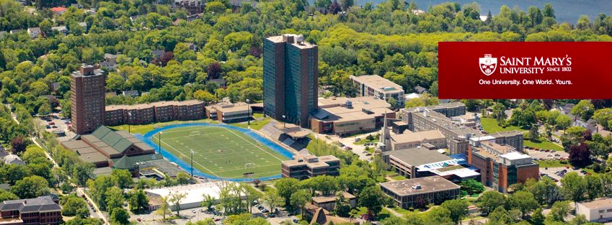

Host Hotel: **Conference Services**

Saint Mary's University

5865 Gorsebrook Avenue   
Halifax, Nova Scotia, Canada   
B3H 3C3

**ROOM REGISTRATION**

Saint Mary’s University is pleased to offer dormitory style accommodations for your participants at the rate of $42.85 per single room and $78.95 per double room.

Hot buffet style breakfast in included and is served daily in the Dockside cafeteria from 7:30-9:00am.

Residences consist of two-bedroom and three bedroom apartments, and a variety of single and double dorm style rooms in suites of six with shared washrooms. Two bedroom apartments have two twin bedrooms (each bedroom has two single beds), a small living/dining room area, kitchen and bathroom. Three bedroom apartments have three single bedrooms (each bedroom has one single bed), kitchen area and bathroom. All bedrooms are furnished as study rooms and have a captain's-style single bed(s), desk(s) with hutches and chair(s). Local phone calls are offered at no additional charge and all linen and towels are supplied. Accessibility of the suites varies, please only request accessible rooms when required.

Reservation Information: Please make your reservations directly with the rooms are blocked under **Jr. East Nationals – Wheelchair Basketball**

Toll Free: 1-888-347-5555

**Parking**

For guests staying in accommodations on campus, parking is provided at no additional charge. The arena parking lot is located on the comer of Inglis Street and Tower Road. Please pick up your parking pass from the Front Desk upon arrival and display it in the front windshield of your vehicle.

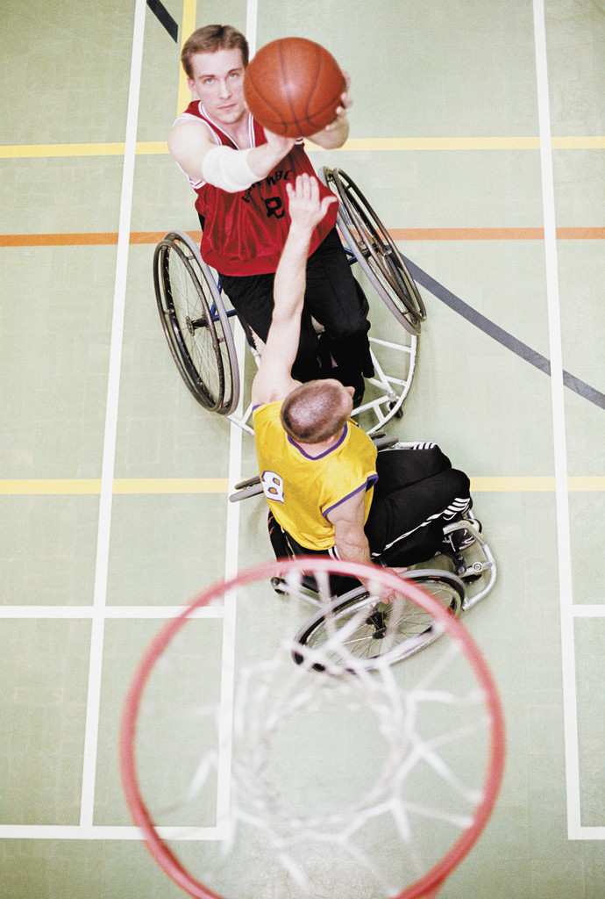

**VAN RENTALS**

Budget Halifax Stanfield International Airport

* 7 passenger minivan 48hrs rental: $207 + tax
* 8 passenger Suburban 48hrs rental: $307 + tax
* 1800-268-8900
* <http://locations.budget.com/ca/ns/enfield/yhz.html>

Aberdeen Tours

* Chartered ≥15 buses to and from airport: prices vary
* Contact for information: 902-850-3377
* info@aberdeentours.

Sport Chairs

* Teams arriving by airplane will be met at arrivals by a Tournament Committee member and will have the team’s sport chairs picked up and delivered to the host facility. Please label them all clearly with team and players names.

**SCHEDULE**

Tournament Schedule:

The tournament schedule will be forwarded as soon as all teams are confirmed and registered.

**BANQUET**

The banquet will be at 7pm on campus (room to be confirmed). It will include supper and activities.

**CLASSIFERS**

Classifiers:

Will be at the gym to classify players during the tournament. If your team has players requiring classification please not this information on the registration forms. Players will be notified of the time and play that the classification will occur.

**COMPETITION FORMAT**

This tournament will use a 3 on 3, two‐division format. One division will use a squad balance rule of 9.0 points, the other will use ‘open points’ (maximum of 5 athletes/squad). Provinces can enter more than one squad in each division. The tournament format will include round robin games, followed by championship games on Sunday, May 14, 2016. The exact schedule will be confirmed once all Provinces/squads have confirmed their attendance.

**OFFICIAL BALL**

Molten GG7

**CONTACT INFORMATION**

NSWBA_Logo_CMYK

**Cher Smith,** Local Host Site

**Nova Scotia Flying Wheels**

**Address:** 20 Kata Court

Hammonds Plains, NS, B3Z 1N7

**Email:** novascotiawheelchairbasketball@gmail.com



**Ryan Lauzon,** Program Coordinator

**Wheelchair Basketball Canada**

**Tel:** 613‐260‐1296 ext. 204

**Email:**  [rlauzo](mailto:rlauzon@wheelchairbasketball.ca)[n@wheelchairbasketball.ca](mailto:n@wheelchairbasketball.ca)

Tournament information and registration forms will also be available on the

Wheelchair Basketball Canada website: [**www.wheelchairbasketball.ca.**](http://www.wheelchairbasketball.ca/)

**Jr. East Regional Championships**

Saint Mary’s University

May 12-14th, 2017 Halifax, NS

Please return your registration form by:

Name of team:           

Team colors:           

Contact person:           

Address:           

Phone and fax:           

Email:           

Players

Class Name Jersey Number Shirt size

                 

Total # of players: \_\_\_\_\_\_\_\_\_\_\_

Staff

Name Title Shirt size

           

           

           

Total # of staff: \_\_\_\_\_\_\_\_\_\_\_\_

Dietary

Does anyone on your team have special dietary concerns? If so, please explain:

                                   

**Transportation**

Team:      \_\_\_\_\_

Method of travel:      \_\_\_\_\_

Airline & Flight #:

Number of people on flight:

Number of additional wheelchairs:

**Arrival:**

Date:      /     /      Time:

Date:      /     /      Time:

**Note:** Please return both forms, with your cheque, to:

20 Kata Court

Hammonds Plains, NS B3Z 1N7

Phone: (902) 222-0064

Email: novascotiawheelchairbasketball@gmail.com

by **April 10th** to enable planning for transportation, t-shirts, and banquet.

**Jr. East Regional Championships**

Saint Mary’s University

May 12-14th, 2017 Halifax, NS

Please complete the following and return with registration. Please email a team photo with this form.

**Team Name:**

**Home City/Province:**

##### **How and when was your team formed?**

**Please list a few of your team’s or team member’s accomplishments. (i.e. National Championships, Tournament Wins, Awards, etc…)**

**Are any of your team members or coaches involved with the National Team Program? If so please provide names and send profiles.**

**List any other interesting facts about your team, players &/or coach(s).**

## Medical Form & Medical Consent Form for Minors

|  |  |  |
| --- | --- | --- |
| **Athlete’s Name:** | | |
| **Address:** | | |
| **Parent’s Telephone:** | **Home:**  **(****)** **-** | **Work:**  **(     )      -** |
| **Emergency Telephone:**  **(     )      -** | | |

I,       give permission for emergency medical/surgical care to be given by the physicians provided by the 2017 Jr. East Regional Championships or by local practitioners as they see fit to select       , who is my son/daughter.

It is understood that wherever possible, I shall be contacted, informed of the problem, diagnosis, treatment required and the expected result.

|  |
| --- |
| Date: |
| Signed: |
| Relationship: |

|  |  |  |  |  |  |  |  |  |  |
| --- | --- | --- | --- | --- | --- | --- | --- | --- | --- |
| Medical Information Form | | | | | | | | | |
| Name: | |  | | | | Height | (cm) | Weight | (kg) |
| Address: | |  | | | | Provincial Health Card: | | | |
|  | | | | | | Next of Kin: | | | |
|  | | | | | | Relationship: | | | |
| Telephone: | | | **(     )      -** | | | Address: | | | |
| Age |  | | | Date of Birth: |  |  | | | |
|  | | | | | | Telephone: **(     )      -** | | | |

|  |  |  |  |
| --- | --- | --- | --- |
| Medical Alert | | | |
| Blood type: |  | Contacts: |  |
| Asthma: |  | Medications: |  |
| Diabetes: |  | Allergies: |  |
| Epilepsy: |  | Hearing Aid: |  |
| Abnormal Heart: |  | Dentures: |  |
| Rheumatic Fever: |  |  |  |
| History of Concussion: |  |  |  |
| General History: |  |  |  |
| Operations: |  |  |  |
| Illness: |  |  |  |
| Parts taped: |  | Parts Braced: |  |
|  |  |  |  |
|  |  |  |  |