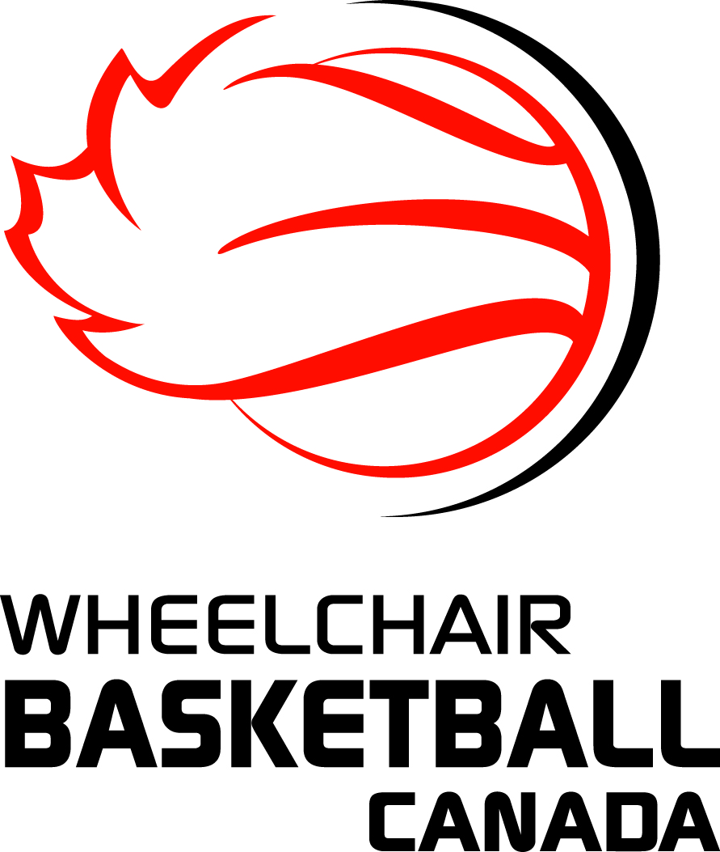
WHEELCHAIR BASKETBALL CANADA

2017-2018 Annual Officials Exam

This examination is open to anyone - official, coach, player or other - and will be used when selecting officials for post-season assignments. To be eligible for those assignments you must complete and pass the 2017-2018 examination by January 28, 2018.

The following documents were used as a basis for the questions in the examination:

- IWBF Rules V1 – December 1, 2017
- IWBF Comments and Interpretations V3 – July 1, 2017

NOTE: Team A is offence; Team B is defence

To properly test yourself, it is recommended that you try to answer these questions on your own, without external assistance, prior to using any resources.

PLEASE USE THE ANSWER SHEET ON PAGE 5 TO RECORD YOUR ANSWERS and THEN EMAIL YOUR ANSWER SHEET TO tkerr@wheelchairbasketball.ca

QUESTIONS
- If there is an angled bar, made up of two or more joined bars between the two front castors, such angle(s) should not exceed more than 200 degrees each. Measurement has to be taken from the external side of the angle. Is this correct?
- A1 in his backcourt passes the ball to A2 who is in his frontcourt. A2 touches the ball which returns to A1 who is still in the backcourt. Team A has caused the ball to be illegally returned into its backcourt. Is this correct?
- B4 lifts from his seat while attempting to block a three point try by A3 which falls well short of the basket. The official assesses a technical foul on B4 and awards A3 with three foul shots for the technical followed by a throw-in at the centre line. Is this the correct procedure?
- Player B1 intercepts a pass in his back court near the 3 point line. A1, who is the last defender between the basket and B1, attempts to play the ball from the side. The contact was not hard but the official whistles the play dead and calls an unsportsmanlike foul on A1. Was the official correct?
- B1 commits an unsportsmanlike foul against A1 on a successful field goal. A1 then commits a technical foul. Two points are awarded to A1 for the made basket. The foul penalties for the unsportsmanlike and the technical foul (1 free throw plus possession for both teams) cancel each other and the official resumes the game with a throw-in at the end line as after any successful field goal. Is this process correct?
- During rebounding action, A1 verbally insults B1 and B1 reacts by punching A1 with his fist. The official signals a double foul? Is this correct?
- During his act of shooting A1 has the ball in both hands when he is fouled by B1. After the foul, A1 passes the ball directly to A2. No free throws are granted. Is this the correct procedure?

- During a time-out team A makes a substitution. After the ball is live the commissioner or assistant scorer realizes that team A is playing in excess of the 14-point limit rule. After Team A is informed and required to make such substitutions as necessary to correct its line up, the coach of team A is charged with a technical foul (“C”). Is this correct?
- A1 is straddling the centre line with two wheels in the frontcourt and two wheels in the backcourt. He receives a pass from a team-mate who is in his backcourt. He then rotates his chair and one of the wheels touching the frontcourt returns to the backcourt. The official signals a violation for illegally returning the ball to the backcourt. Was the official correct?
- The eight-second count will end when A4, in his backcourt, deliberately taps the ball onto B2 who is in A’s frontcourt and the ball returns to A4 in his backcourt without touching the floor in the frontcourt. Is this correct?
- A player shall be disqualified for the reminder of the game when he is charged with one technical foul and one unsportsmanlike foul. Is this correct?
- With 17 seconds remaining on the shot clock, A1 releases a shot for a field goal. While the ball is in the air B2 commits a foul on A2. It is team B's 2nd foul in the period. The ball hits the ring but does not enter the basket. The ball shall be awarded to team A for a throw-in at the place nearest to the infraction and, because of the foul, the shot clock shall be reset to 24 seconds.
- A1 is fouled at the footrest bar, which extends into the 2-point field goal area, by B4 during a 3-point attempt. Neither of A1´s large wheels but both of A1’s castors are in the 2-point field goal area. In the case of an unsuccessful goal, A1 will receive 2 free throws. Is this correct?
- A player causes all parts of his wheelchair to come off the floor while one hand is removed from the rear wheels. No technical foul should be charged to this player. Is this correct?
- Play is stopped after A1’s wheelchair breaks an axle and team A’s equipment manager is having difficulties making an immediate repair. If the repair cannot be completed in 60 seconds or less from the time the game was stopped, the official will instruct team A to (1) remove the damaged chair, and (2) A1 must be substituted. Is this correct?
- A free-throw shooter positions his chair some distance away from the free-throw line but within the semi-circle. He moves forward during the free throw, crosses the free-throw line with his small front wheel(s) or castor(s) and the ball touches the ring before either of the rear wheels touches the free-throw line. Is this a free-throw violation?
- A2’s backcourt pass, with the count at 6 sec., hits A3’s chair which is completely in the frontcourt. The ball bounces back to Team A’s backcourt where it is recovered by A2. The referee whistles the play down as his count is now at 8 sec. Is the referee correct?
- Before the referee tosses the ball for the tap-off to commence the game, the commissioner notices that team A has more than 14 points in its starting line-up. The Game Commissioner advises the referee. Shall the referee charge the Team A coach with a “C” technical foul?
- The tap-off between A1 and B1 to start the game has gone out of bounds after touching B4. A1 who is taking the ball out of bounds makes a pass to A2 and wants to come onto the playing surface. There is no room because B4 is directly in front of her within one meter of the endline. A1 rolls along the endline and attempts to enter but B4 rolls parallel to A4 and blocks her entry. The official stops play and assesses B4 with a technical foul. Was he correct to do this?
- Simultaneously with the game clock signal for the end of the first period, B1 commits an unsportsmanlike foul on A1. A1 shall attempt 2 free throws with no line up of players and no playing time remaining. After the 2 minutes interval of play, the game shall be resumed with a throw-in by team A at the centre line extended, opposite the scorer’s table. Team B shall lose its right to the next alternating possession throw-in at the next tap-off situation. Is this correct?
- A1 released the ball on a shot from the 3-point field goal area. The ball on its upward flight is legally touched by a B3 who is within team A's 2-point field goal area. The ball then continues its flight and enters the basket. Team A shall be awarded 3 points. Is this correct?

- A1, who is contesting a tap-off at the beginning of the game, lifts from his seat but fails to touch the ball. Since A1 did not touch the ball, a technical foul shall not be charged against him and the game shall continue. Is this the correct procedure?
- Substitute B7 is beckoned to enter the court. Instead of entering the court at the point where she was positioned, she moves down the sideline and wants to enter the court near her team bench area. A5 moves down the sideline and, without contacting B7, prevents B7 from entering the court. Is this action by A5 legal?
- Team A is in control of the ball with 10 seconds remaining on the shot clock when a held ball occurs. The alternating possession throw-in is awarded to Team A. Depending on where the held ball occurred, Team A shall have a new 14 or 24 second shot clock period. Correct?
- A doctor cannot enter the playing court without the permission of an official even if, in the doctor's judgement, the injured player requires immediate medical treatment. Is this correct?
- On a shot for a field goal by A1 with 9 seconds showing on the shot clock, the ball lodges between the ring and the backboard. Team A is entitled to a throw-in under the alternating possession procedure. After the throw-in team A will have 9 seconds remaining on the shot clock. Is this correct?
- A1 is leaning forward to retrieve a ball from the floor and raises his buttocks so that both cheeks are no longer in contact with the seating platform of the wheelchair or the cushion where a cushion is used on the wheelchair. The official calls a technical foul on A1. Was he correct?
- As the official is about to hand the ball to A5 for a frontcourt throw-in he notices A2 has not left the restricted area. He assesses Team A with a throw-in violation and awards the ball to Team B. Is this the correct procedure?
- A chair may only be checked during a game when it is on the court in the possession of a player. It is not an infraction to be sitting at the bench area on a chair that does not conform to Art.3.1. Are these statements correct?
- A1 is moving with the ball toward the basket and B1 is moving parallel with him. A1’s footrest is ahead of B1’s footrest. A1 slightly brakes his inner wheel in order to get in a better position for his layup. B1 contacts A1 with his footrest and the contact causes A1 to fall out of his chair. The official calls a foul on B1. Was the official correct?

PLEASE USE THE ANSWER SHEET ON THE FOLLOWING PAGE TO RECORD YOUR ANSWERS AND THEN EMAIL ONLY THAT PAGE TO: tkerr@wheelchairbasketball.ca

WBC EXAMINATION ANSWER SHEET
2017-2018

1 |  | 6 |  | 11 |  | 16 |  | 21 |  | 26
2 |  | 7 |  | 12 |  | 17 |  | 22 |  | 27
3 |  | 8 |  | 13 |  | 18 |  | 23 |  | 28
4 |  | 9 |  | 14 |  | 19 |  | 24 |  | 29
5 |  | 10 |  | 15 |  | 20 |  | 25 |  | 30

EMAIL ONLY THIS PAGE TO: tkerr@wheelchairbasketball.ca

