Memorandum
To:  From:  Date:  Subject: | Wheelchair Basketball Canada Active Members  Wendy Gittens, Executive Director  September 18, 2018  Nominations Report
Please accept this as the 2018 Nominations Report for Wheelchair Basketball Canada.
A call for nominations was sent to all active members, following the provisions as outlined in article III Election and Appointment of Directors of the Wheelchair Basketball Canada Bylaw document. The following names have been submitted for election:
1. President (2 year term)
Steve Bach
2. VP Marketing and Communications (2 year term) Kathy Newman
3. VP Athlete Representative (2 year term)
Brandon Wagner
4. VP High Performance vacant
Regards,
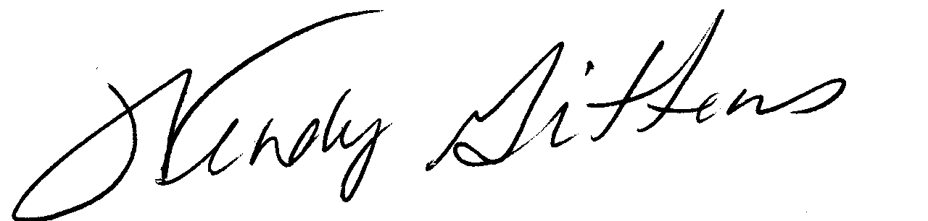
____________
Wendy Gittens
Executive Director

